

# Team 24 – Sprint 1 Testing Document

Sakshi Choudhary, Giorgi Khmaladze, Nick Litman, Mihir Somani, Conley Utz

# User Story #12

**Test 1: Testing all created pages are responsive, and have correct redirection.**

Purpose: To meet the acceptance criteria, the user should be able to easily view and navigate our minimalistic page from any device they so please. Each test was tested on an iPhone X and a regular browser on computer.

Steps:

1. The user can view the signin.php page on all devices. 

**iPhone X Google Chrome Browser on Computer** 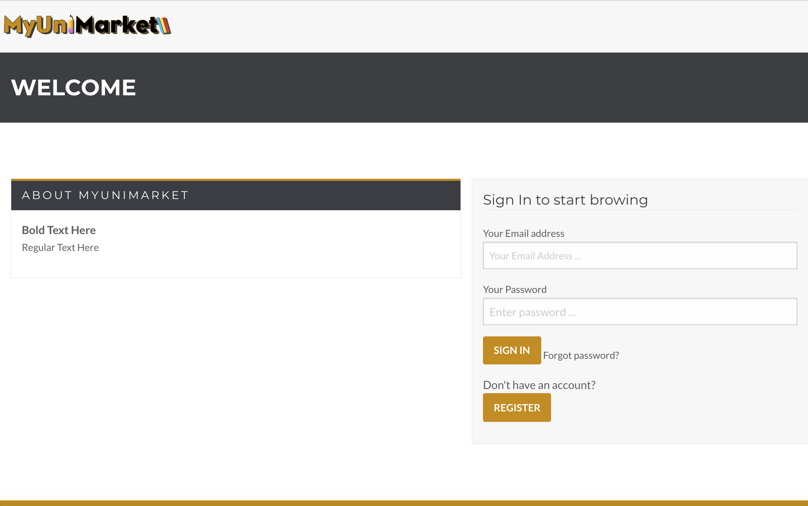

1. The user can view the signup.php page on all devices.

**iPhone X Google Chrome Browser on Computer** 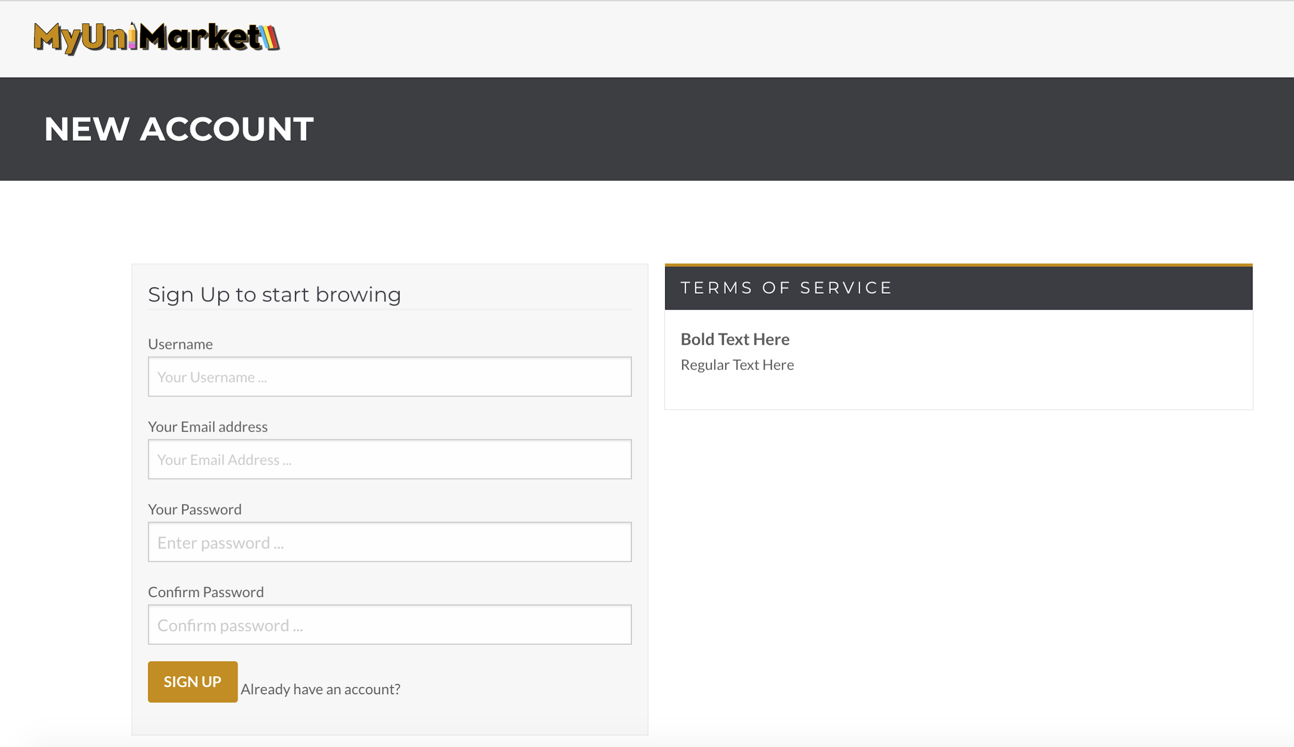

1. The user can view the create.php page on all devices.

**iPhone X Google Chrome Browser on Computer** 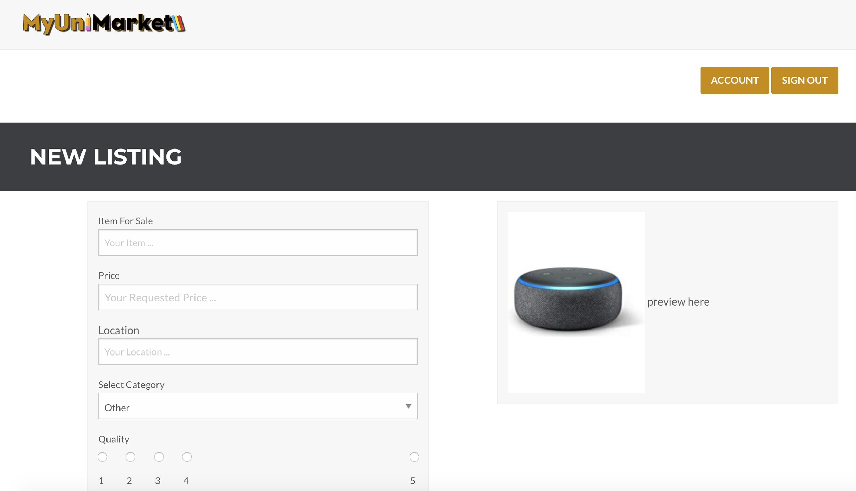

1. The user can view the account.php page on all devices.

**iPhone X Google Chrome Browser on Computer** 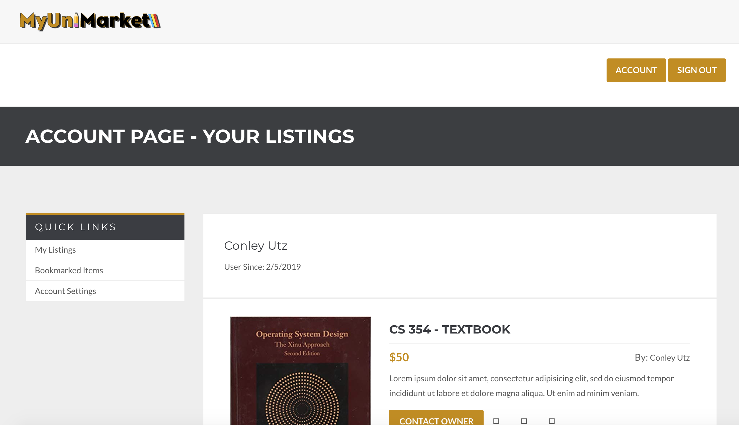

1. The user can view the account2.php page on all devices.

**iPhone X Google Chrome Browser on Computer** 

Expected Result: User is successfully able to view and navigate website across devices.

Test Result: **PASSED**